**Introduction:** This lab teaches about the setting up of integral to learn about the Fourier Coefficients for a periodic signal in MATLAB. It also teaches on how to investigate the Gibbs Phenomenon.

II. Lab Assignment

1.

% FSmain.m

% Calculates the Fourier series through symbolic cacluations

clear all

syms t;

% Time Signal parameters

tau = 2; % length of signal

T0 = 4; % fundamental period

tshift = 1; % time shift from signal centered at 0

amp = 1; % amplitude of signal

baseline = 0.5; % DC bias

% !!!IMPORTANT!!!: the signal definition must cover [0 to T0]

% the signal is defined over [-T0, 2T0], which covers [0, T0]

N = 10; % number of components +/- to compute

k_vec = [-N:N];

xt = amp*(heaviside(t+tau/2-tshift)-heaviside(t-tau/2-tshift) + heaviside(t- (T0-tau/2)-tshift) ...

-heaviside(t-(T0+tau/2)-tshift))+ heaviside(t+T0-tshift)*baseline;

% Compute FS coefficients

[X, w] = FourierSeries(xt, T0, k_vec);

% plot the results from Matlab calculation

figure();subplot(211);

% plot magnitude and phase separately

stem(w,abs(X), 'o-');

xlabel('Frequency (rad/sec)');ylabel('Magnitude');

hold on;subplot(212);

stem(w,angle(X), 'o-');

xlabel('Frequency (rad/sec)');ylabel('Phase');

For this signal parameter T0=4, amp=1, N=10.

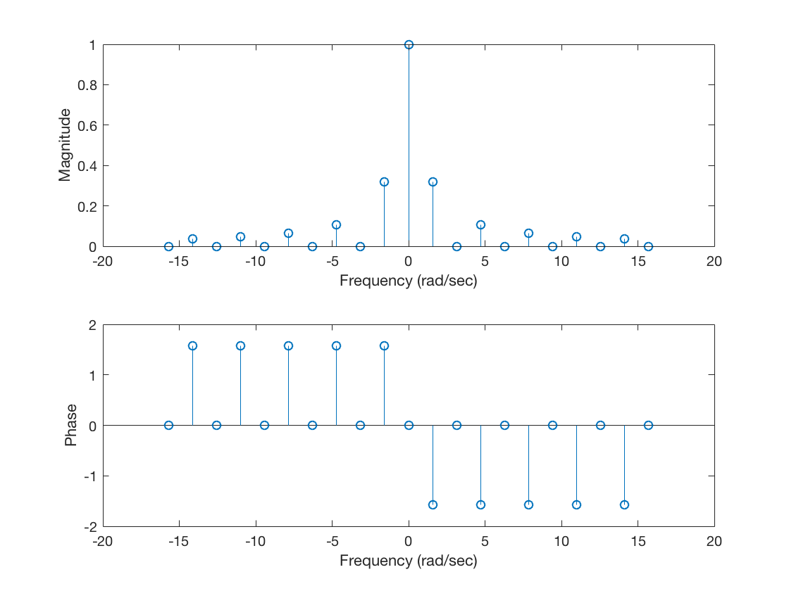

2.

% FSmain.m

% Calculates the Fourier series through symbolic cacluations

clear all

syms t;

% Time Signal parameters

tau = 2; % length of signal

T0 = 4; % fundamental period

tshift = 1; % time shift from signal centered at 0

amp = 2; % amplitude of signal

baseline = 1; % DC bias

% !!!IMPORTANT!!!: the signal definition must cover [0 to T0]

% the signal is defined over [-T0, 2T0], which covers [0, T0]

N = 10; % number of components +/- to compute

k_vec = [-N:N];

xt = amp*(heaviside(t+tau/2-tshift)-heaviside(t-tau/2-tshift) + heaviside(t- (T0-tau/2)-tshift) ...

-heaviside(t-(T0+tau/2)-tshift))+ heaviside(t+T0-tshift)*baseline;

% Compute FS coefficients

[X, w] = FourierSeries(xt, T0, k_vec);

% plot the results from Matlab calculation

figure();subplot(211);

% plot magnitude and phase separately

stem(w,abs(X), 'o-');

xlabel('Frequency (rad/sec)');ylabel('Magnitude');

hold on;subplot(212);

stem(w,angle(X), 'o-');

xlabel('Frequency (rad/sec)');ylabel('Phase');

For this signal parameter T0=4, amp=2, baseline=1, N=10.

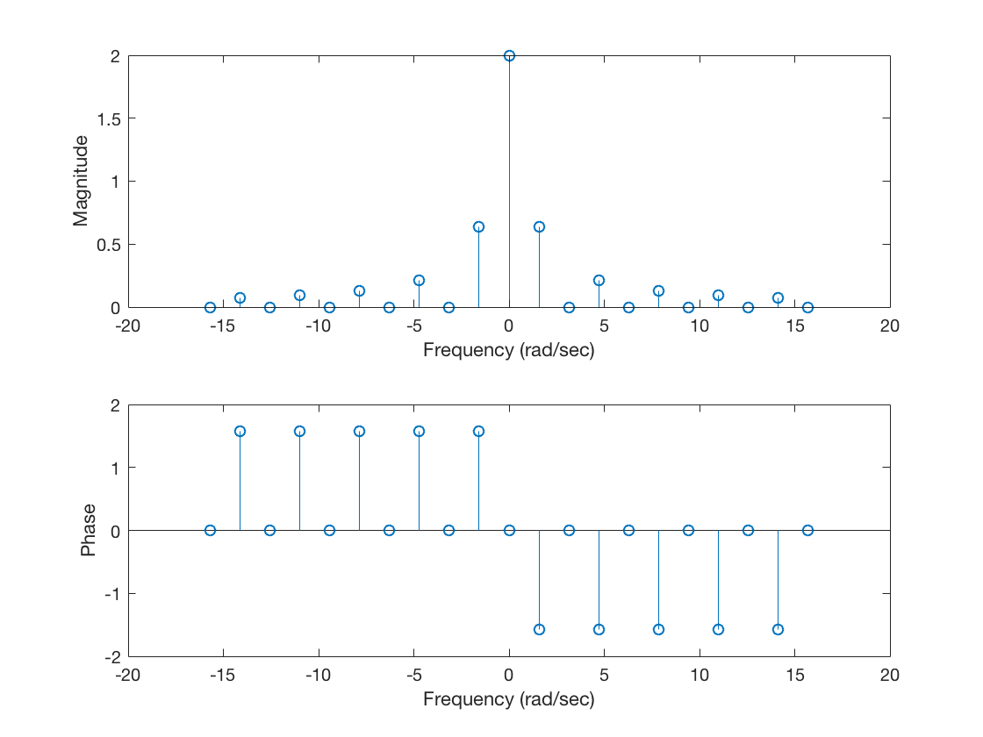

3.

% FSmain.m

% Calculates the Fourier series through symbolic cacluations

clear all

syms t;

% Time Signal parameters

tau = 2; % length of signal

T0 = 4; % fundamental period

tshift = 1; % time shift from signal centered at 0

amp = 1; % amplitude of signal

baseline = 0; % DC bias

% !!!IMPORTANT!!!: the signal definition must cover [0 to T0]

% the signal is defined over [-T0, 2T0], which covers [0, T0]

N = 10; % number of components +/- to compute

k_vec = [-N:N];

xt = amp*(heaviside(t+tau/2-tshift)-heaviside(t-tau/2-tshift) + heaviside(t- (T0-tau/2)-tshift) ...

-heaviside(t-(T0+tau/2)-tshift))+ heaviside(t+T0-tshift)*baseline;

% Compute FS coefficients

[X, w] = FourierSeries(xt, T0, k_vec);

% plot the results from Matlab calculation

figure();subplot(211);

% plot magnitude and phase separately

stem(w,abs(X), 'o-');

xlabel('Frequency (rad/sec)');ylabel('Magnitude');

hold on;subplot(212);

stem(w,angle(X), 'o-');

xlabel('Frequency (rad/sec)');ylabel('Phase');

For this signal parameter T0=4, amp=1, baseline=0, N=10.

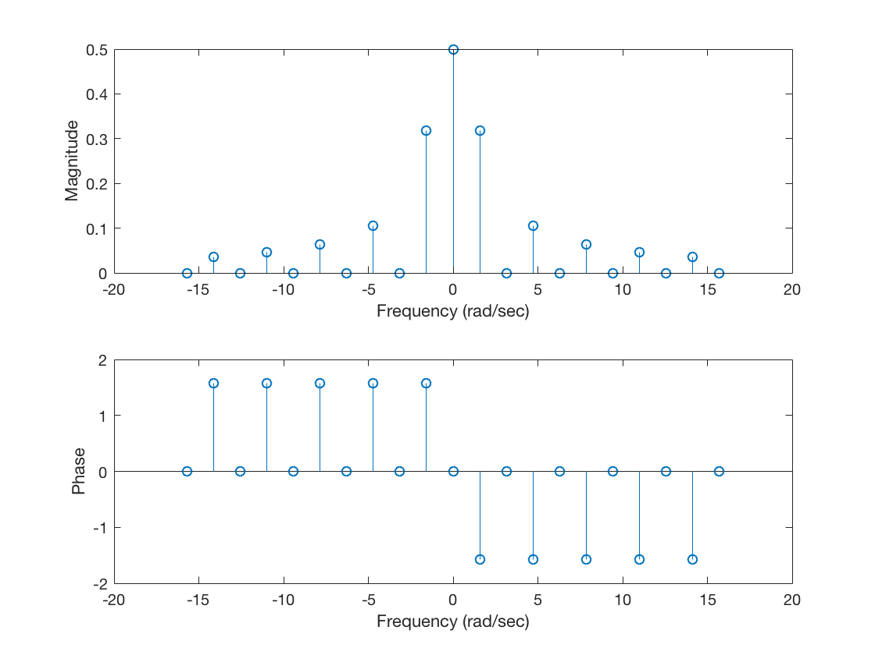

4.

% FSmain.m

% Calculates the Fourier series through symbolic cacluations

clear all

syms t;

% Time Signal parameters

tau = 1; % length of signal

T0 = 4; % fundamental period

tshift = 2; % time shift from signal centered at 0

amp = 1; % amplitude of signal

baseline = 0.5; % DC bias

% !!!IMPORTANT!!!: the signal definition must cover [0 to T0]

% the signal is defined over [-T0, 2T0], which covers [0, T0]

N = 10; % number of components +/- to compute

k_vec = [-N:N];

xt = amp*(heaviside(t+tau/2-tshift)-heaviside(t-tau/2-tshift) + heaviside(t- (T0-tau/2)-tshift) ...

-heaviside(t-(T0+tau/2)-tshift))+ heaviside(t+T0-tshift)*baseline;

% Compute FS coefficients

[X, w] = FourierSeries(xt, T0, k_vec);

% plot the results from Matlab calculation

figure();subplot(211);

% plot magnitude and phase separately

stem(w,abs(X), 'o-');

xlabel('Frequency (rad/sec)');ylabel('Magnitude');

hold on;subplot(212);

stem(w,angle(X), 'o-');

xlabel('Frequency (rad/sec)');ylabel('Phase');

For this signal parameter T0=4,tshift=2, amp=1, N=10.

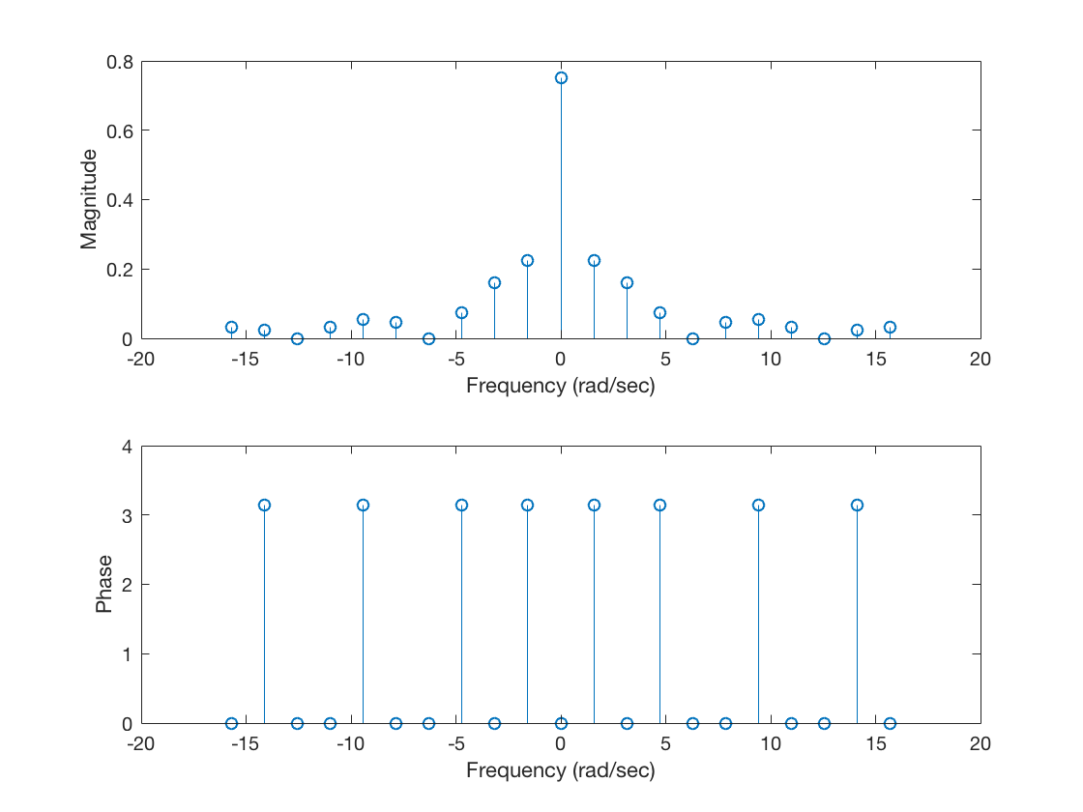

5.

FSmain.m

% Calculates the Fourier series through symbolic cacluations

clear all

syms t;

% Time Signal parameters

tau = 2; % length of signal

T0 = 7; % fundamental period

tshift = 1; % time shift from signal centered at 0

amp = 1; % amplitude of signal

baseline = 0.5; % DC bias

% !!!IMPORTANT!!!: the signal definition must cover [0 to T0]

% the signal is defined over [-T0, 2T0], which covers [0, T0]

N = 10; % number of components +/- to compute

k_vec = [-N:N];

xt = amp*(heaviside(t+tau/2-tshift)-heaviside(t-tau/2-tshift) + heaviside(t- (T0-tau/2)-tshift) ...

-heaviside(t-(T0+tau/2)-tshift))+ heaviside(t+T0-tshift)*baseline;

% Compute FS coefficients

[X, w] = FourierSeries(xt, T0, k_vec);

% plot the results from Matlab calculation

figure();subplot(211);

% plot magnitude and phase separately

stem(w,abs(X), 'o-');

xlabel('Frequency (rad/sec)');ylabel('Magnitude');

hold on;subplot(212);

stem(w,angle(X), 'o-');

xlabel('Frequency (rad/sec)');ylabel('Phase');

For this signal parameter T0=7, tshift=1, amp=1, N=10.

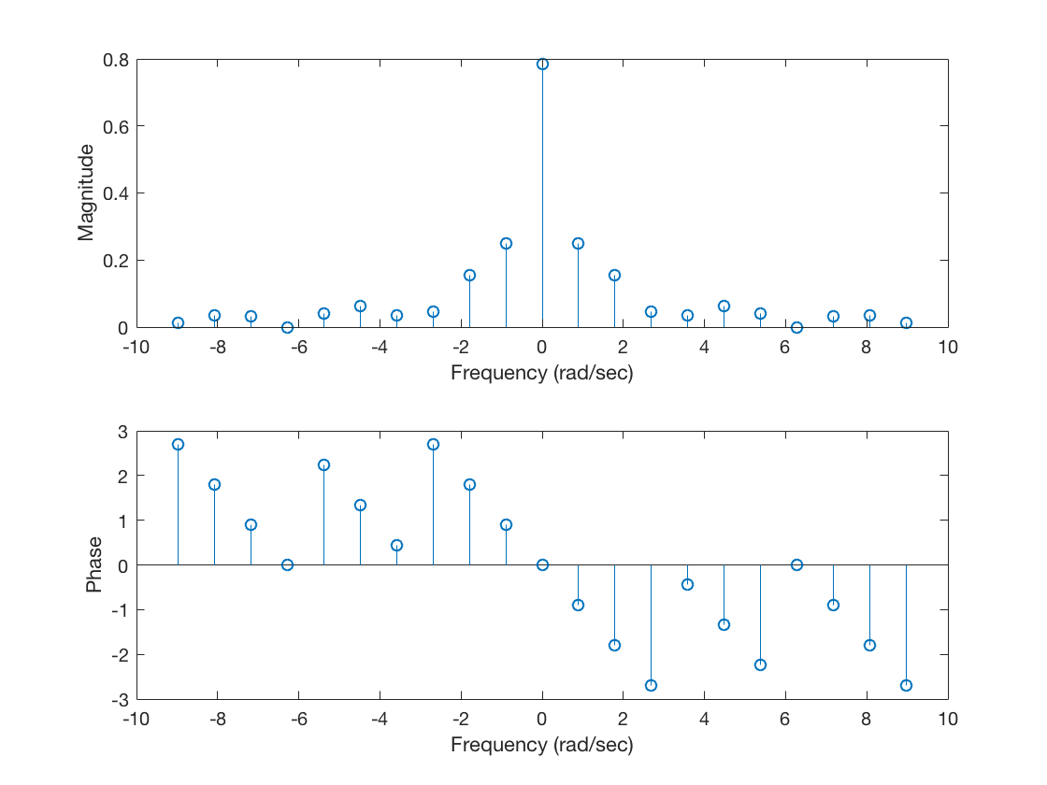



For N=5:

function [xt,dt] = FSsynthesis_Square(N, T0, a0, Range);

N=5;% N number of components to use

T0=4;% T0 fundamental period in seconds of the square wave

a0=0;% a0 DC component

%Range - plotting range for signal, 2x1 vector

n_vec = [1:N];

Omega0 = 2*pi/T0;

f0 = 1/T0;

% Compute the Fourier series coefficients for a square wave

a_k = zeros(size(n_vec));

% odd indexed components only have non-zero values

a_k(1:2:end) = 1./(j*n_vec(1:2:end)*Omega0);

dt = 1/(N*f0*10);

t = [0:dt:4];

xt = zeros(size(t));

for m = 1:length(n_vec)

    xt = xt + a_k(m)*exp(j*n_vec(m)*Omega0*t)+conj(a_k(m))*exp(-j*n_vec(m)*Omega0*t);

end

xt = xt + a0*ones(size(t));

figure();

plot(t,xt)

title(['Fourier Approximation for N = ', num2str(N)]);

xlabel(['time']); ylabel(['x(t)']);

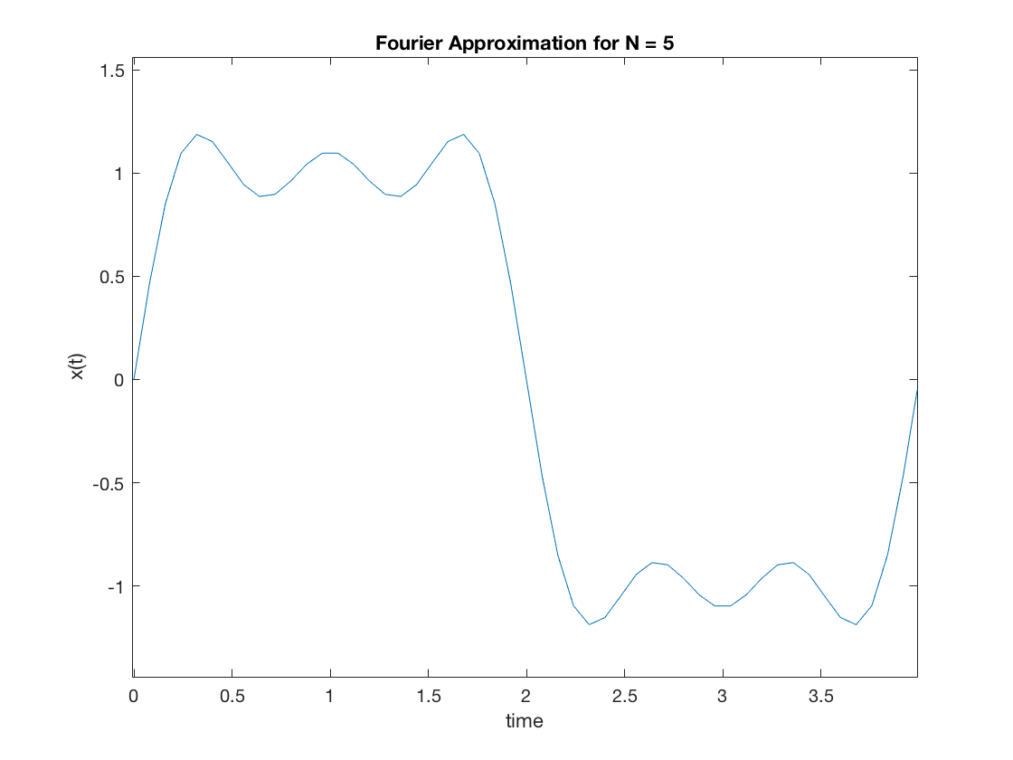

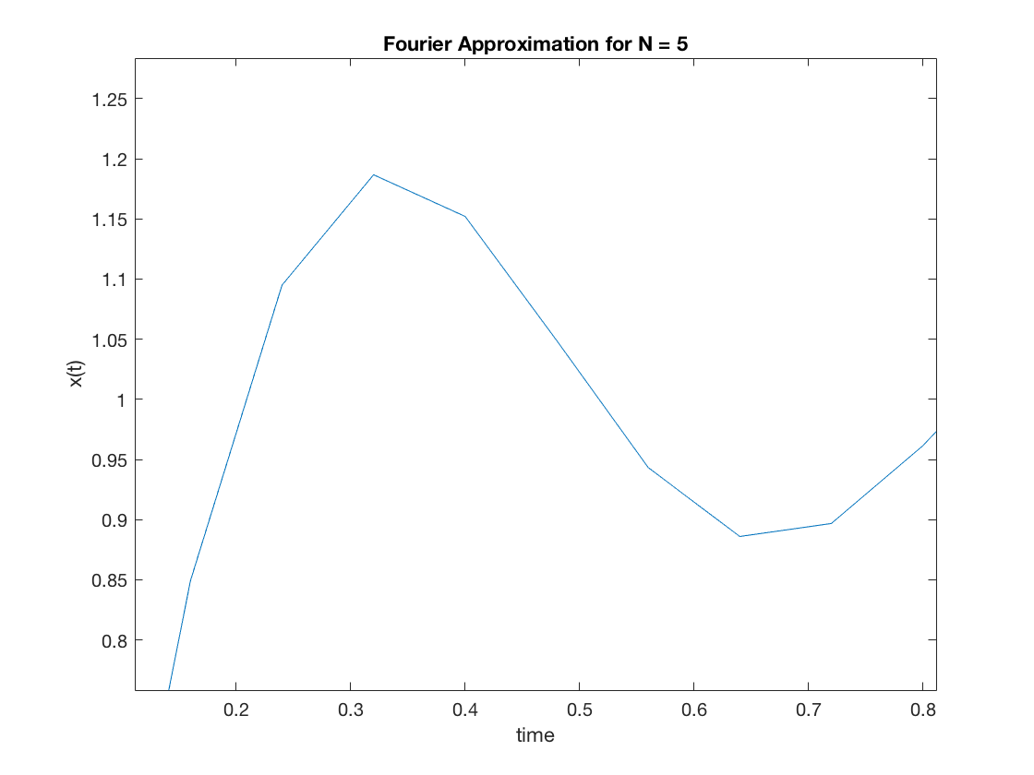

For N = 13:

function [xt,dt] = FSsynthesis_Square(N, T0, a0, Range);

N=13;% N number of components to use

T0=4;% T0 fundamental period in seconds of the square wave

a0=0;% a0 DC component

%Range - plotting range for signal, 2x1 vector

n_vec = [1:N];

Omega0 = 2*pi/T0;

f0 = 1/T0;

% Compute the Fourier series coefficients for a square wave

a_k = zeros(size(n_vec));

% odd indexed components only have non-zero values

a_k(1:2:end) = 1./(j*n_vec(1:2:end)*Omega0);

dt = 1/(N*f0*10);

t = [0:dt:4];

xt = zeros(size(t));

for m = 1:length(n_vec)

    xt = xt + a_k(m)*exp(j*n_vec(m)*Omega0*t)+conj(a_k(m))*exp(-j*n_vec(m)*Omega0*t);

end

xt = xt + a0*ones(size(t));

figure();

plot(t,xt)

title(['Fourier Approximation for N = ', num2str(N)]);

xlabel(['time']); ylabel(['x(t)']);

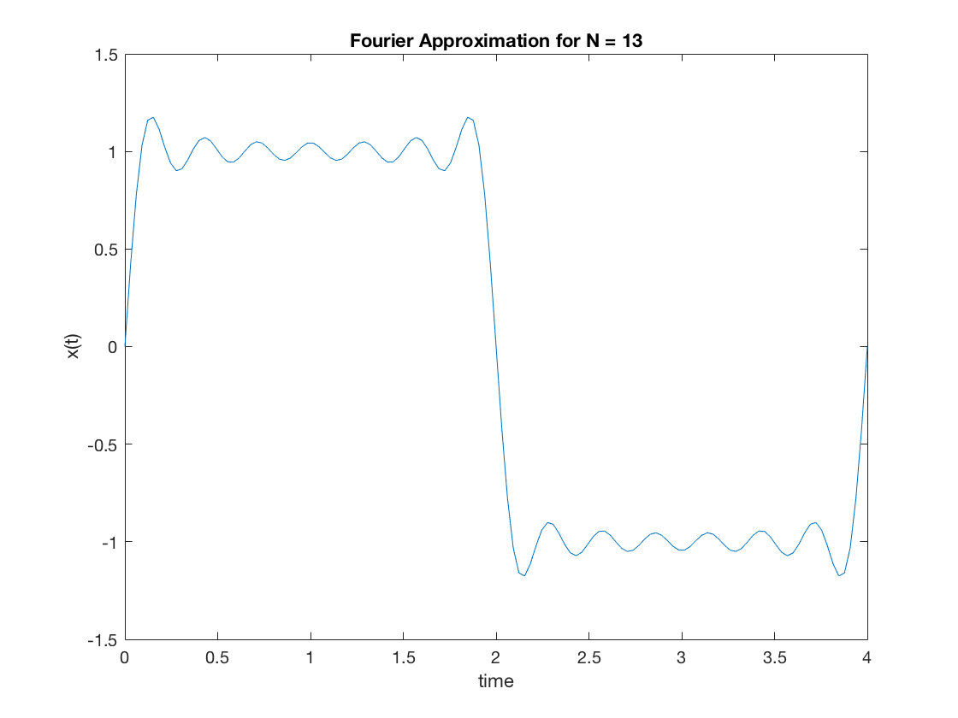

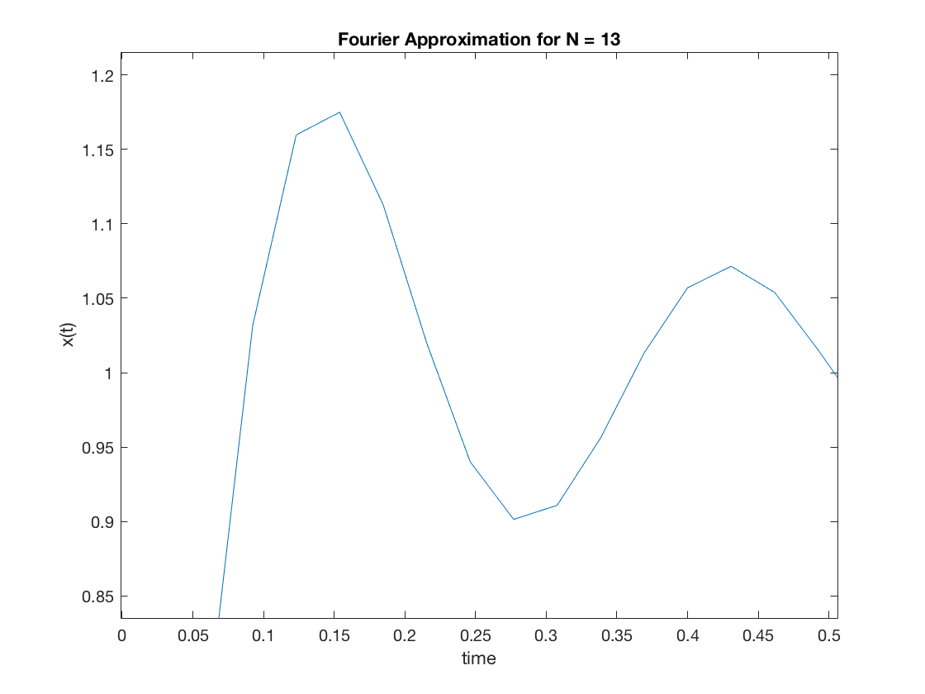

For N = 23:

function [xt,dt] = FSsynthesis_Square(N, T0, a0, Range);

N=23;% N number of components to use

T0=4;% T0 fundamental period in seconds of the square wave

a0=0;% a0 DC component

%Range - plotting range for signal, 2x1 vector

n_vec = [1:N];

Omega0 = 2*pi/T0;

f0 = 1/T0;

% Compute the Fourier series coefficients for a square wave

a_k = zeros(size(n_vec));

% odd indexed components only have non-zero values

a_k(1:2:end) = 1./(j*n_vec(1:2:end)*Omega0);

dt = 1/(N*f0*10);

t = [0:dt:4];

xt = zeros(size(t));

for m = 1:length(n_vec)

    xt = xt + a_k(m)*exp(j*n_vec(m)*Omega0*t)+conj(a_k(m))*exp(-j*n_vec(m)*Omega0*t);

end

xt = xt + a0*ones(size(t));

figure();

plot(t,xt)

title(['Fourier Approximation for N = ', num2str(N)]);

xlabel(['time']); ylabel(['x(t)']);

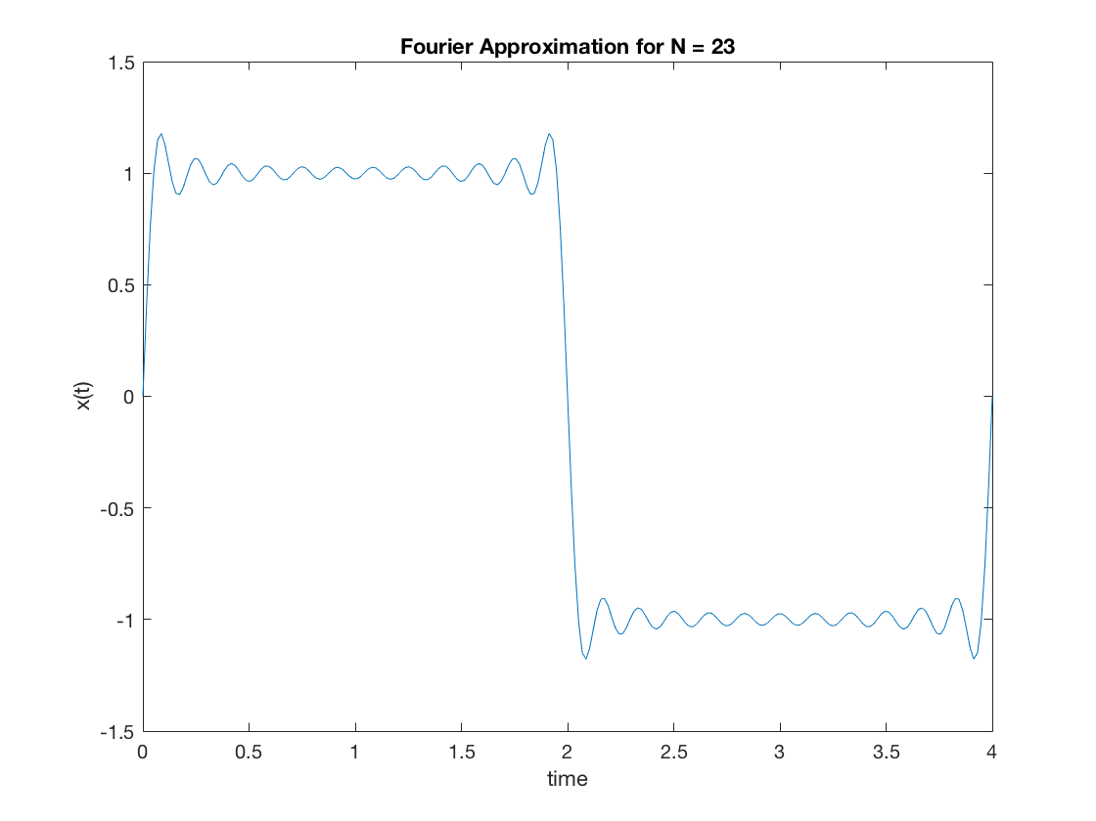

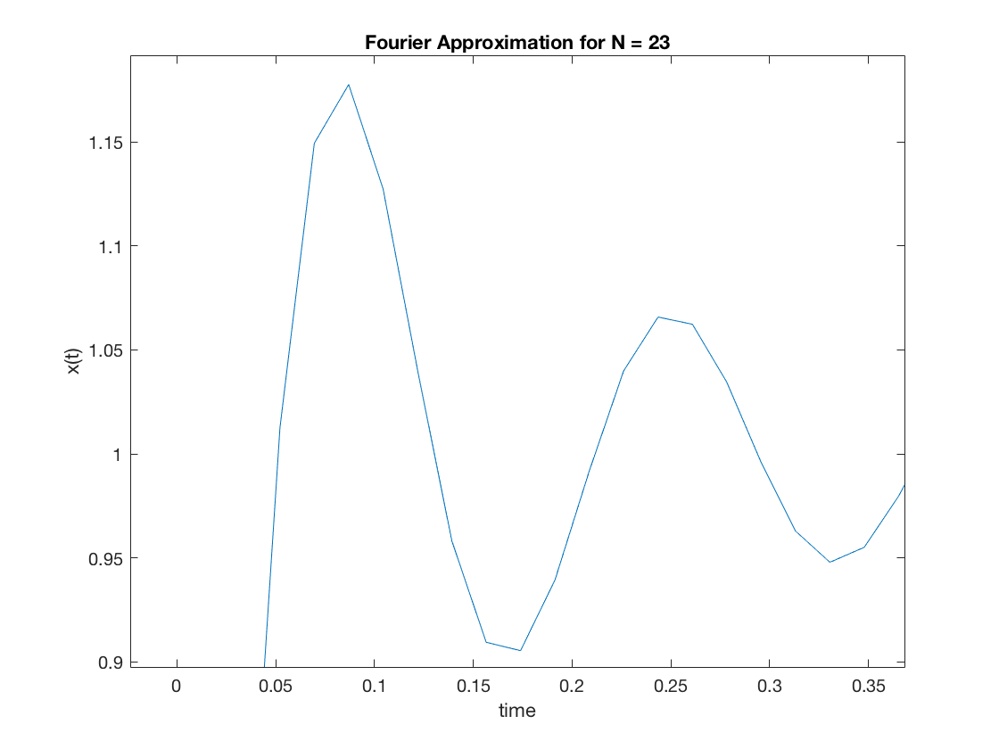

For N=99:

function [xt,dt] = FSsynthesis_Square(N, T0, a0, Range);

N=99;% N number of components to use

T0=4;% T0 fundamental period in seconds of the square wave

a0=0;% a0 DC component

%Range - plotting range for signal, 2x1 vector

n_vec = [1:N];

Omega0 = 2*pi/T0;

f0 = 1/T0;

% Compute the Fourier series coefficients for a square wave

a_k = zeros(size(n_vec));

% odd indexed components only have non-zero values

a_k(1:2:end) = 1./(j*n_vec(1:2:end)*Omega0);

dt = 1/(N*f0*10);

t = [0:dt:4];

xt = zeros(size(t));

for m = 1:length(n_vec)

    xt = xt + a_k(m)*exp(j*n_vec(m)*Omega0*t)+conj(a_k(m))*exp(-j*n_vec(m)*Omega0*t);

end

xt = xt + a0*ones(size(t));

figure();

plot(t,xt)

title(['Fourier Approximation for N = ', num2str(N)]);

xlabel(['time']); ylabel(['x(t)']);

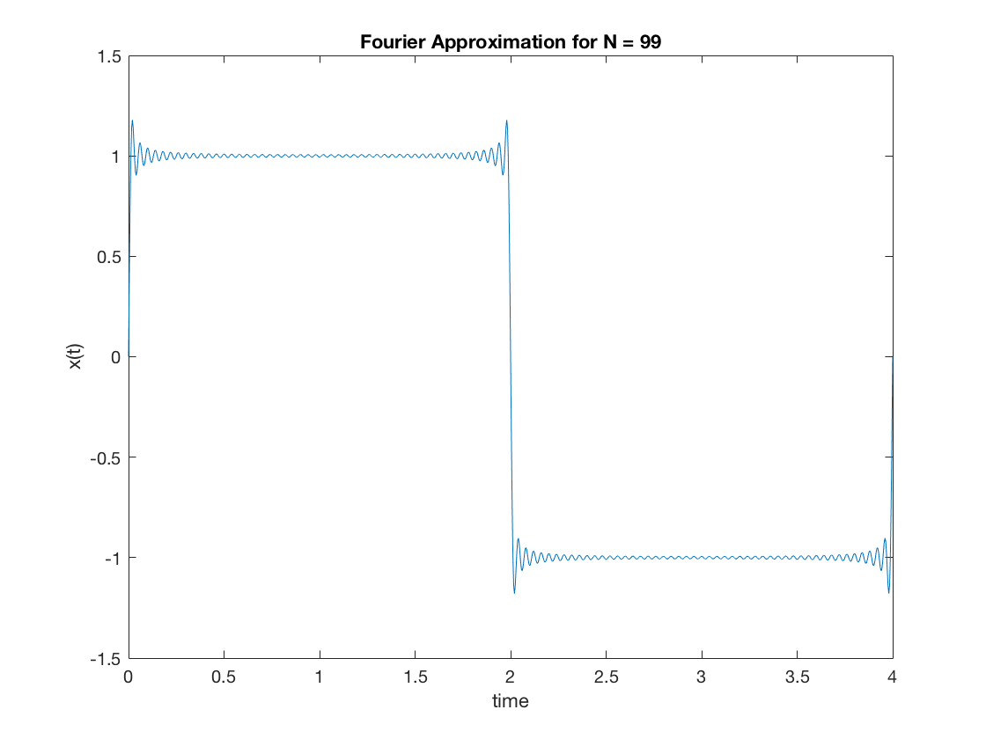

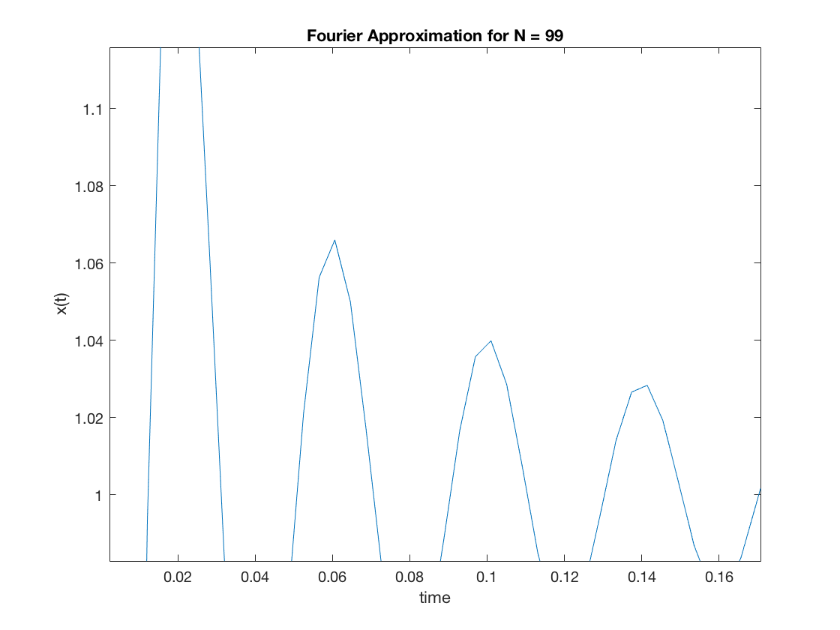

|  |  |
| --- | --- |
| Value of N | Width of overshoot |
| N=5 | 0.30 |
| N=13 | 0.16 |
| N=23 | 0.10 |
| N=99 | 0.02 |

So, as N increases, the height of the overshoot tends to almost remains the same, but the width of overshoot keeps on decreasing.